GUI Description

The Header, which contains the logo of the gym, menu and profile icon which acts as a button that links to the profile page and it has a JavaScript function as it disappears when there is no logged in user session.

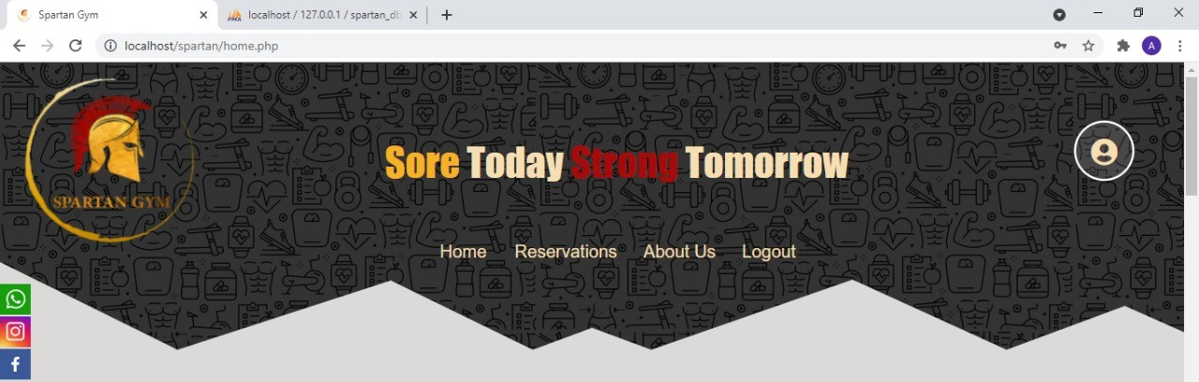

Home page: includes some pictures of the gym, floating social icons and some information about the gym. The home page is made with a user-friendly interface to access all the website pages and make reservations and get to know the gym better.

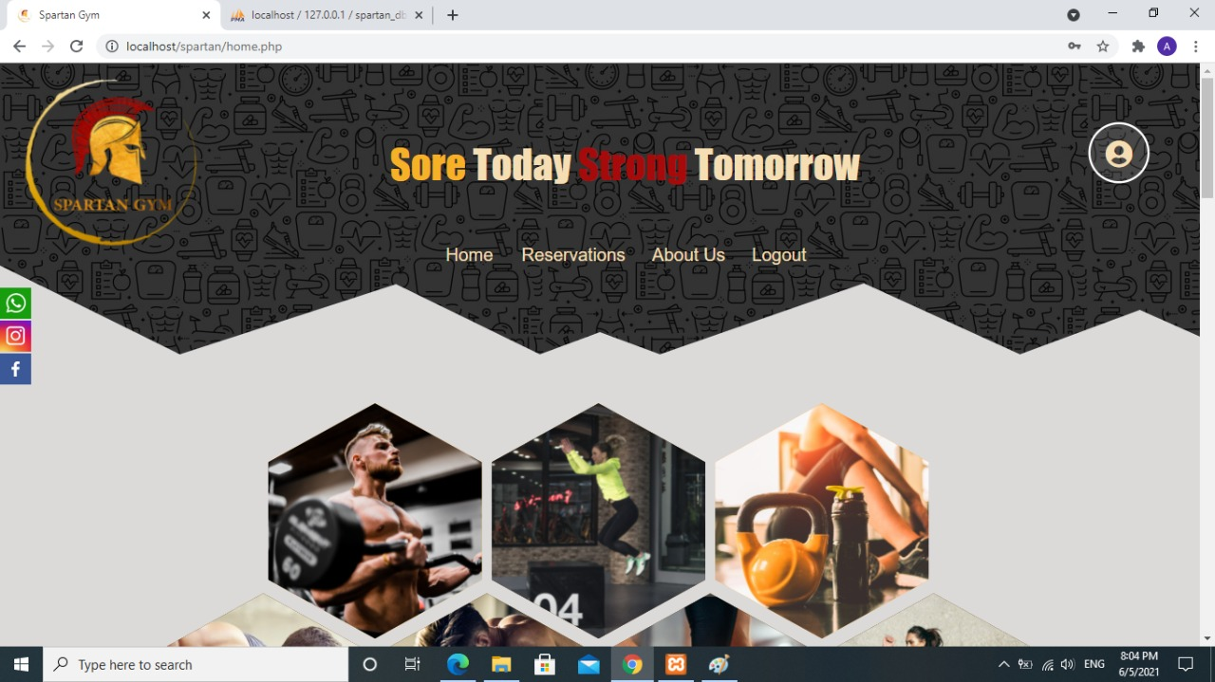

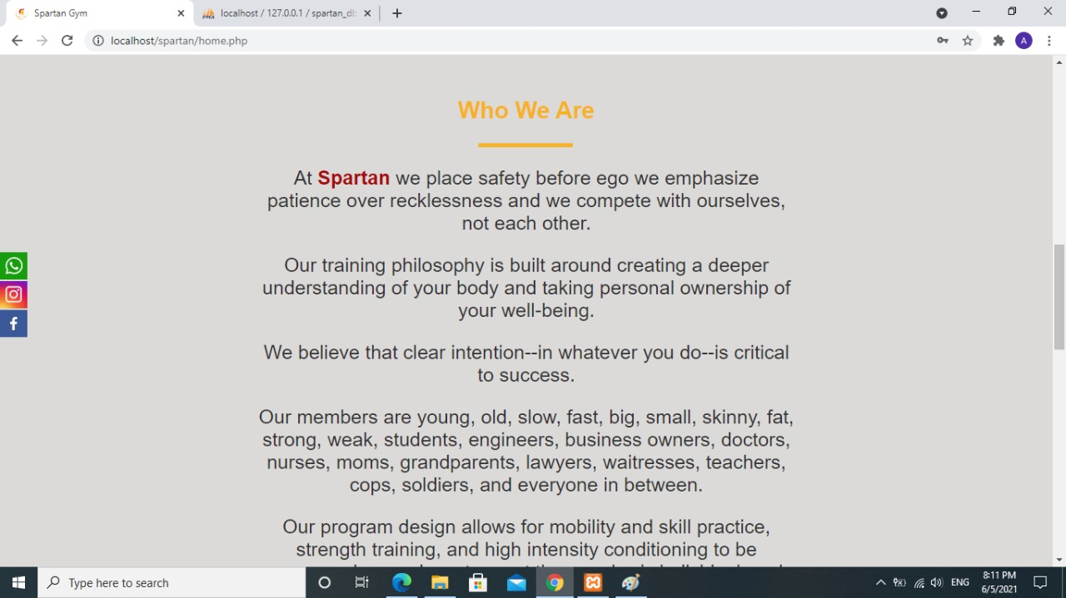

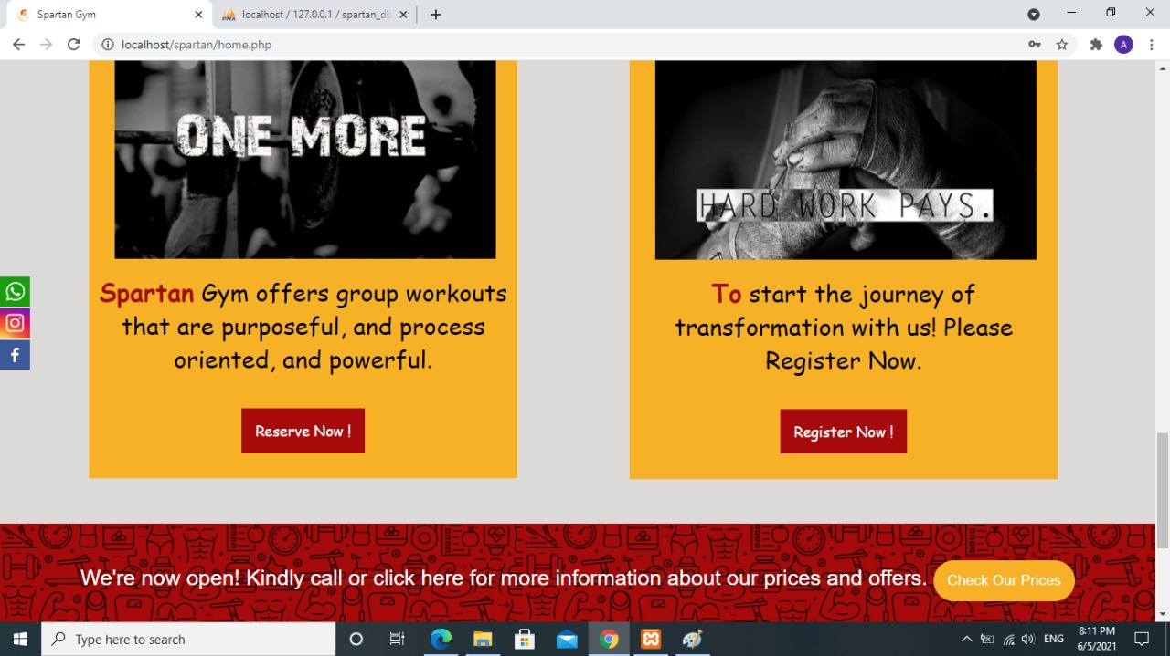

Menu: helps you to go through different pages in an effective simple way. The login button was made with a JavaScript function so that when there is a started php session it is changed to logout, and the logout button then can end the session.



Reservations: user in this page can book training sessions that helps the gym to schedule their sessions and to avoid crowding during the current pandemic.by providing his name, email and phone etc., user can complete a reservation but first he must login. user also provide his Id which is only stored and given to him by the gym when subscribing. The reservation form is directly inserted into the database if there is no errors or empty fields.

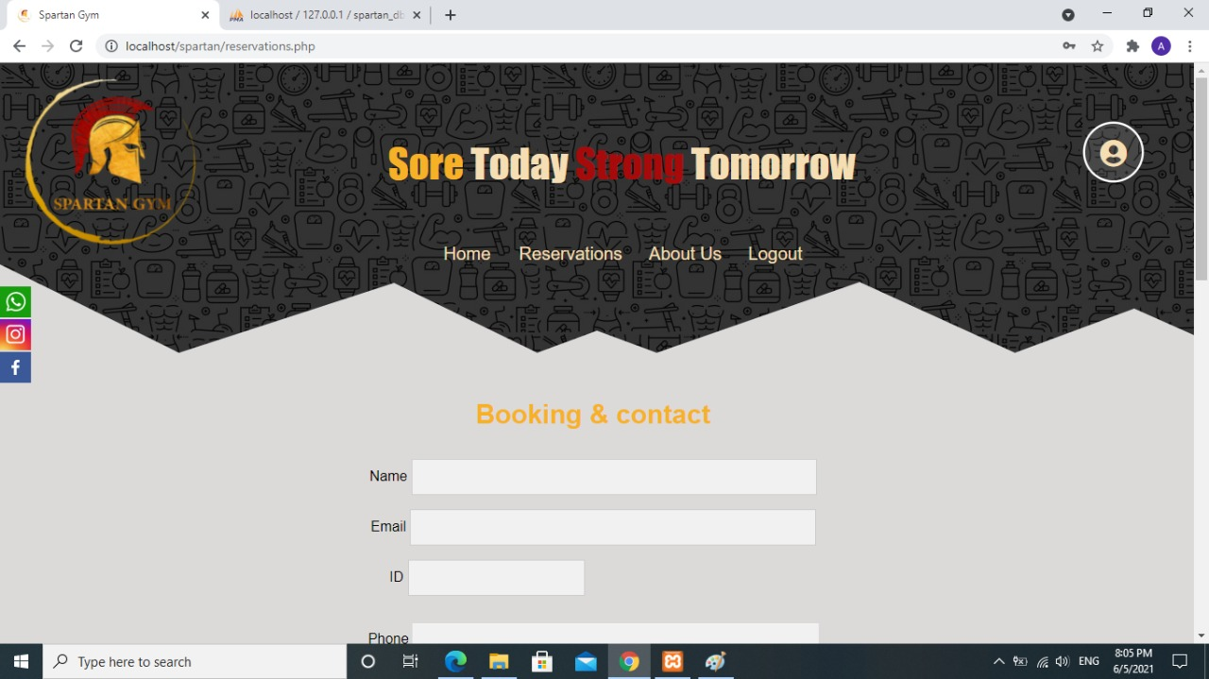

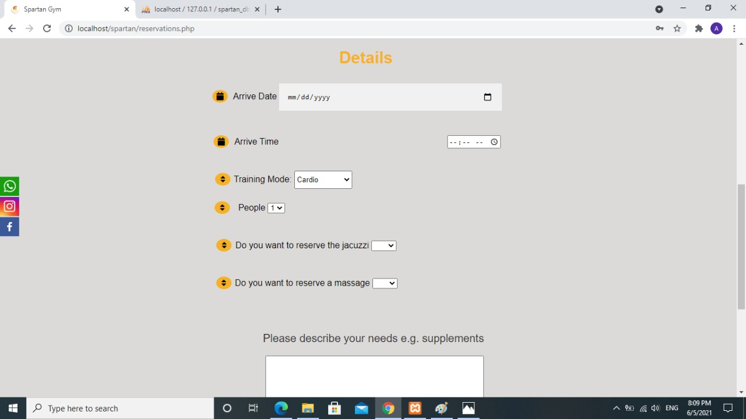

About us: lead to the last page of the site, about us is an unclickable drop button that contains three different links to three different pages:

Each page of those contains a side-nav menu that make wandering between about us pages much more easier.

First, the contact us page: which contains all gym information as the gym location map, social icons, contacting numbers, emails and working hours.

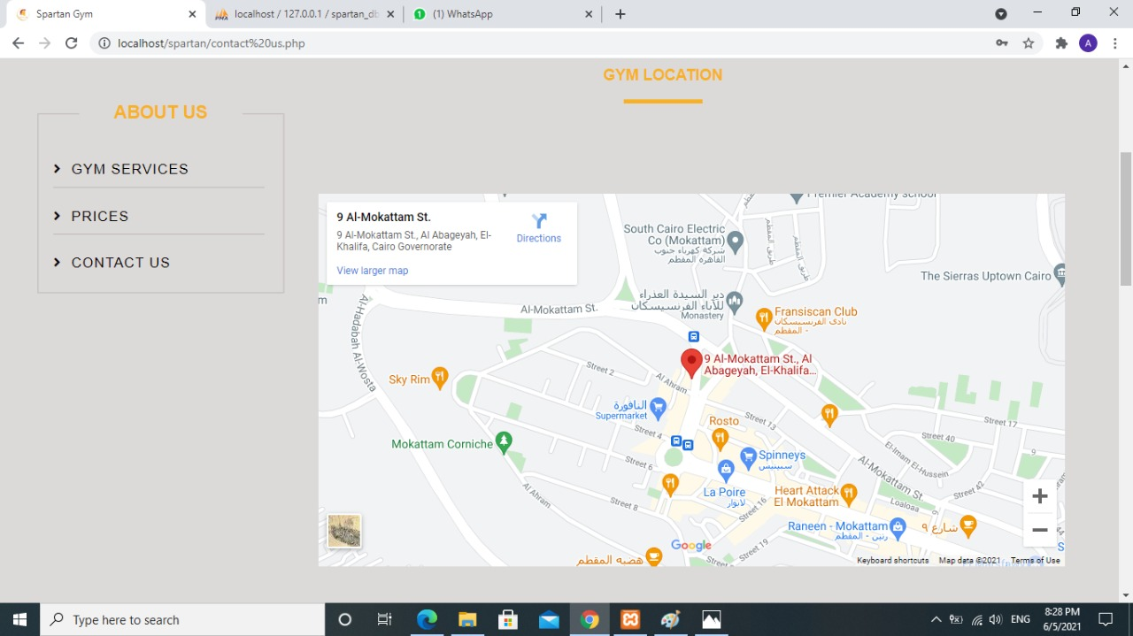

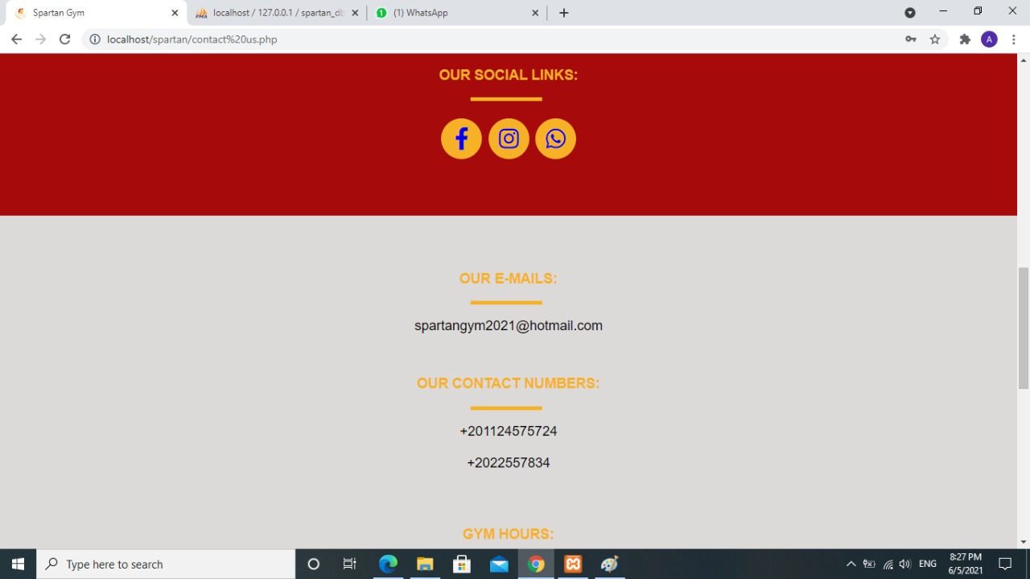



Second, the prices page which contains prices of the subscription in the gym and sessions.

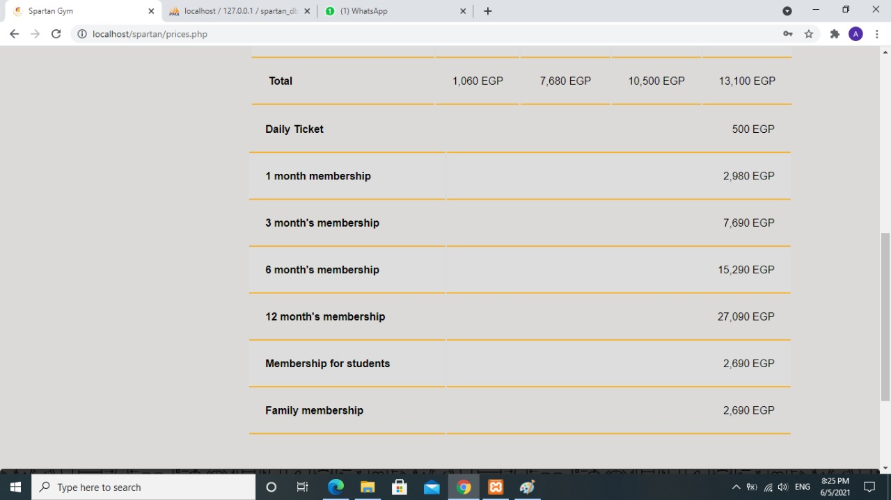

Third, the gym services page which shows users features and services provided by Spartan Gym.

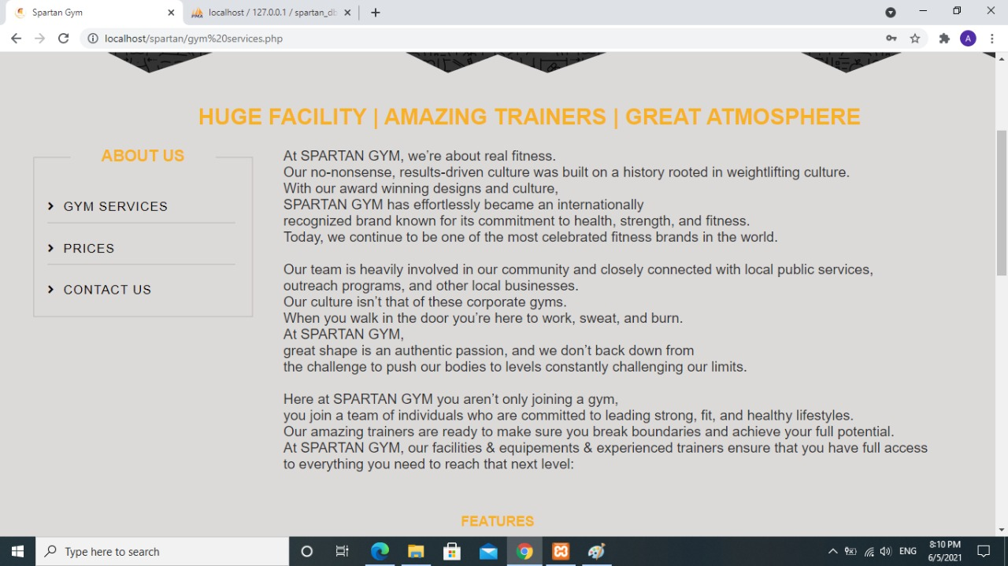

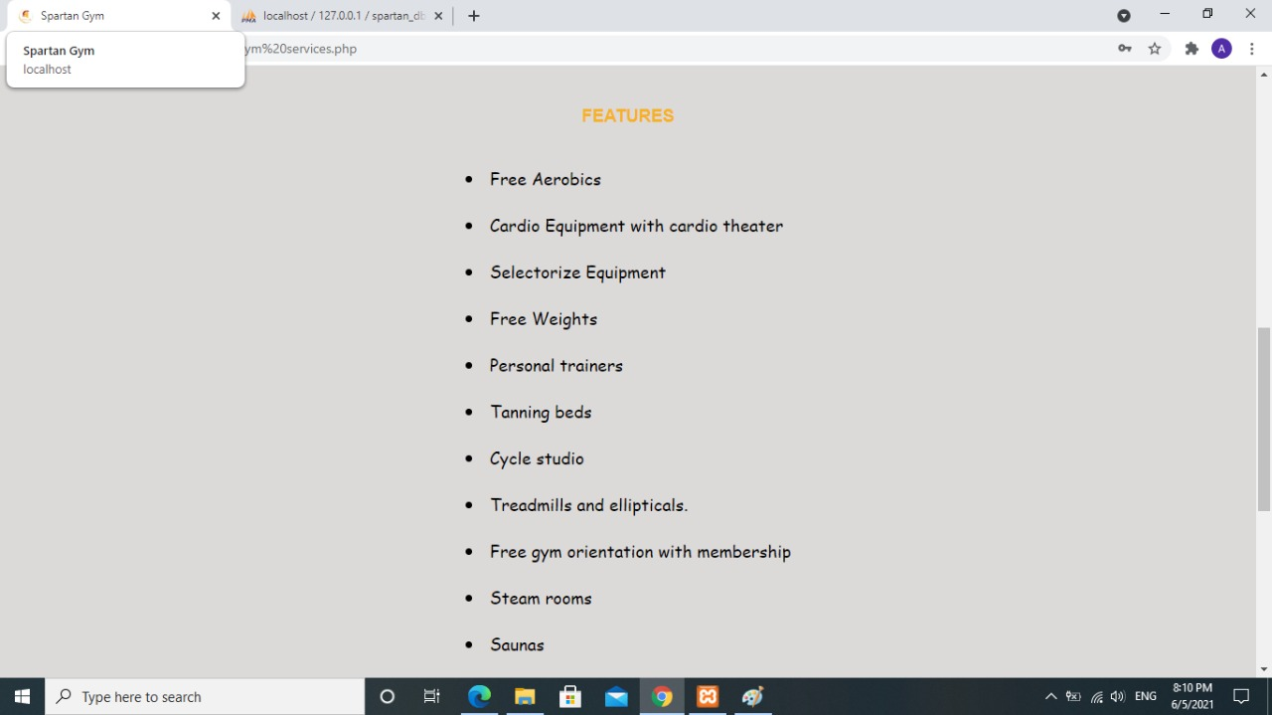

Register Page: the page contains registration form that allows the user to create an account by inserting information about him which is required, to be able to reserve sessions. After registration is complete the user gets an alert to login.

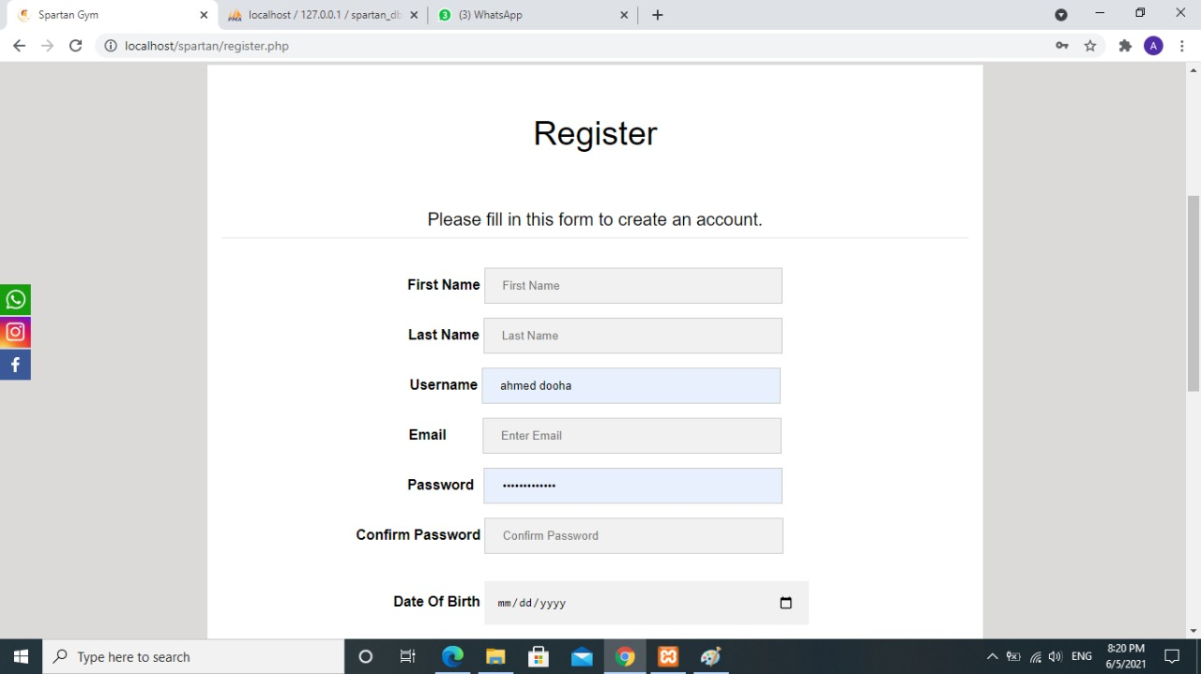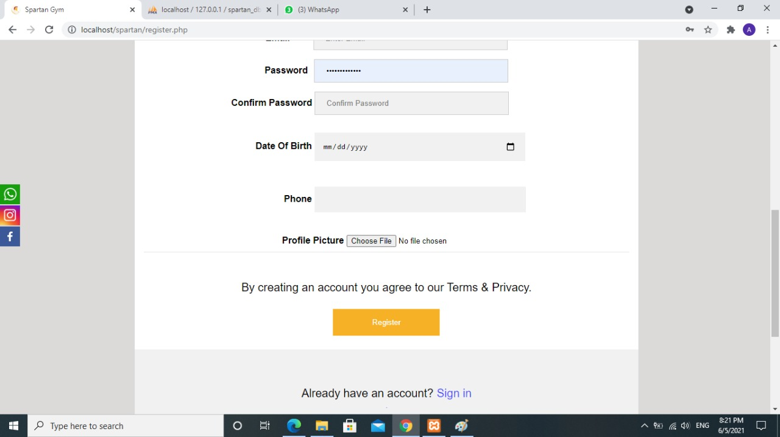

Profile Page: consists of user card and reservation table. Users can't access profile page unless they are logged in.

User card displays some info about the logged in user which he inserted into the register form earlier: user’s profile picture, user’s full name and user’s username. User easily can change his password by clicking “change password” in the user card which displays a form by a JavaScript function, user inserts the current password and the new password which he wishes to change to.

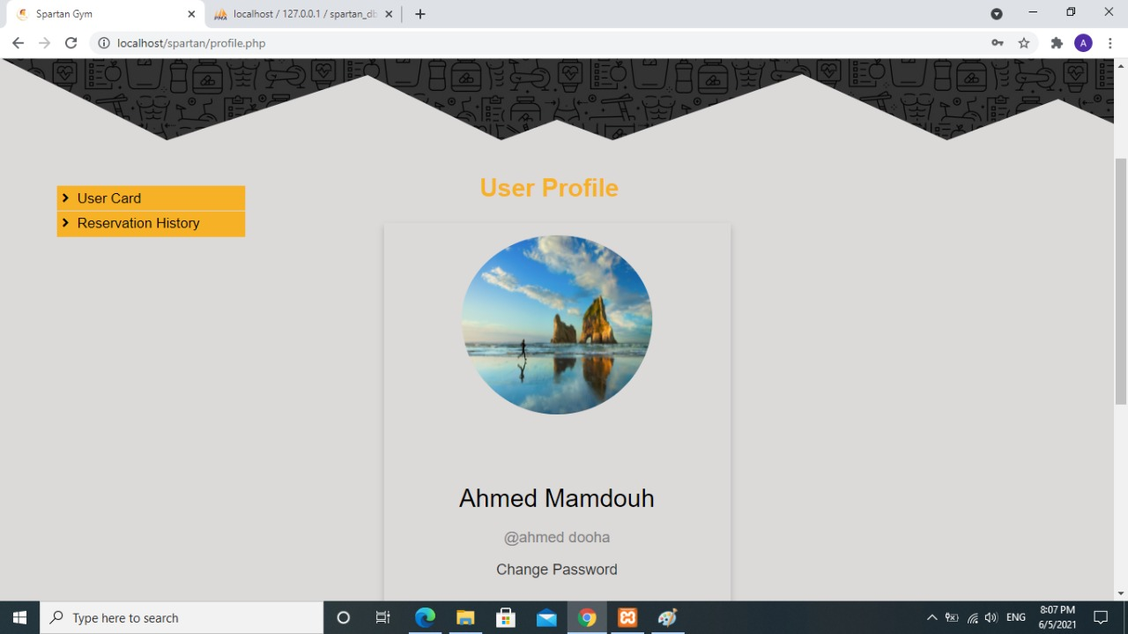

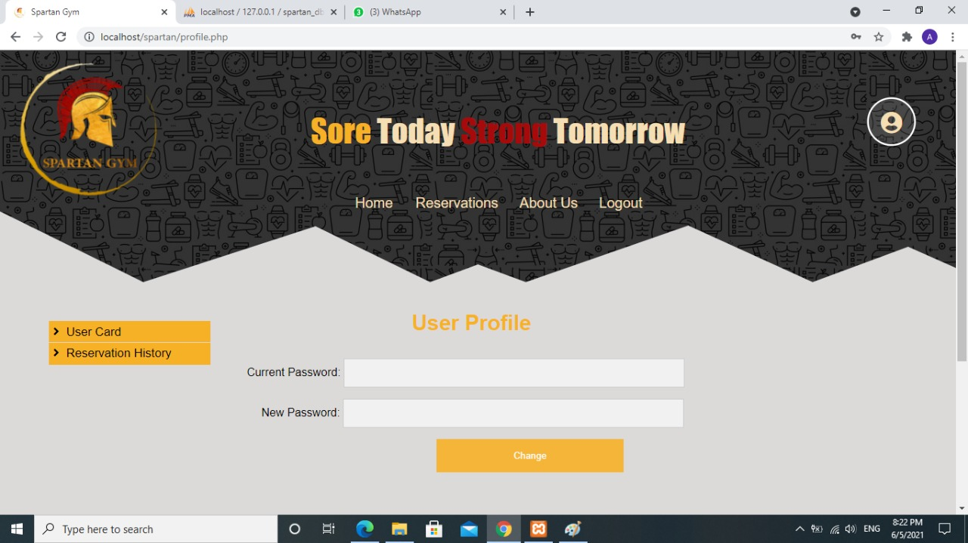

Reservation History, a button which displays a table of reservations the logged in user made. The table is displayed by a JavaScript function & some simple CSS.

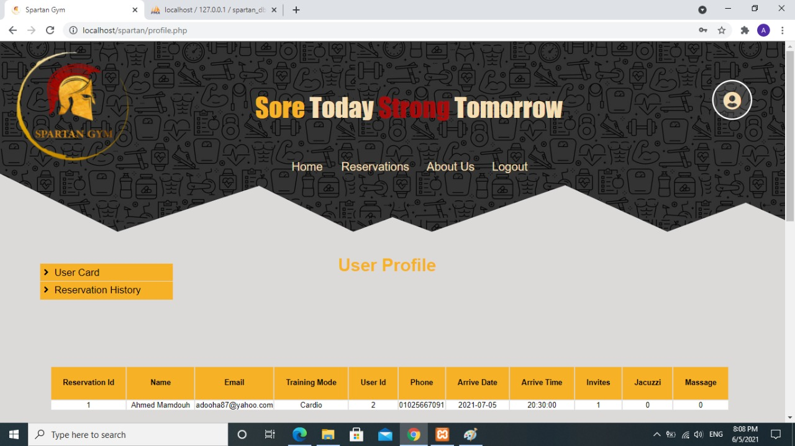

The Footer contains three columns, first column contains phone numbers of the gym. Second column contains emails, and the third column contains directions to the gym and a direct link to google maps. At the end of the footer there is a copy right section.

